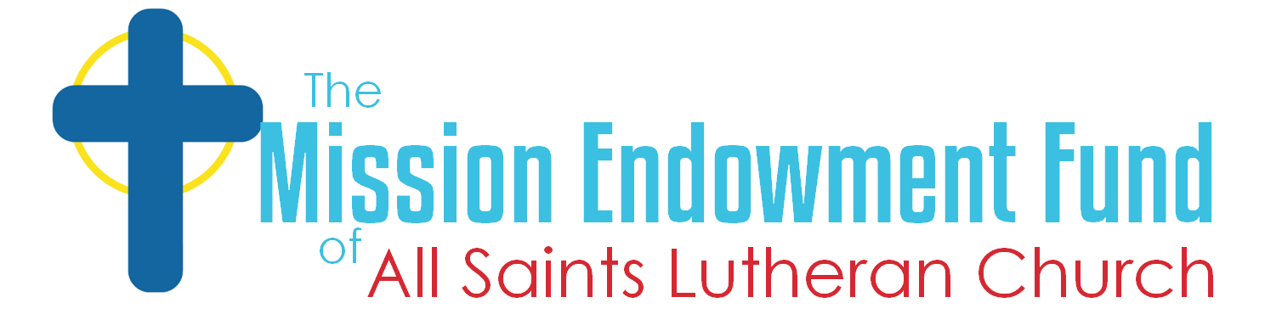

All Saints Lutheran Church (ASLC)
Mission Endowment Fund (MEF) Grant Application

It is a blessing and an honor to offer this opportunity to your organization. God has graciously provided this congregation with this opportunity to serve others.
In 2026, grant requests should range from $500 to $ 2,000. Only legally registered 501(c)(3) nonprofit organizations are eligible for these grants.
If your organization qualifies, please complete the application by answering each question.
The 2026 application deadline is August 1. The MEF Trustees will contact you to confirm they received your completed form. Applications will be contacted by the Trustees by November 1 with a decision, and funds will be distributed by check by November 30, 2026.
If you have any questions, don't hesitate to get in touch with the chair of our trustees, Chris Totten, at MEF.chair@gmail.com.
For your convenience, the sections of this online form will be:
- Name and Tax Status Eligibility
- Information About the Organization
- The Request
- Program/Project Details (if applicable)
- Final Questions

Section 1 of 4 Name and Tax Status Eligibility
Item 1: Legal Name of the Organization: Description:
Item 2: Tax Status Eligibility
Description by IRS:
Item 3: IRS EIN:

Section 2 of 4 Information About the Organization
Item 1: Organization’s Contact Points
Item: 2: Organization Website URL: https://
Description
Short text answer:
Item 3: Organization’s Mission and/or Vision Statement:
Long answer on the purpose of the Organization as well as the statements of mission and vision.
Item 4: Geographic area served by the Organization:

Section 3 of 4 The Request
Item 1: The Grant Amount Requested:
Please provide the grant amount being requested.
Item 2: Usage of Funds
Will this grant be used for project support or for operating support? Yes or No, explain.
Item 3: Project Support, complete the section below. Operating Support need not complete the section below:
- What is the Program/Project title?
- Is this a new or ongoing Program/Project? Identify the actual or projected start-up date
- If this request only covers a part of a larger project, how much does the total project cost, and how will this grant amount be used within that project? Please provide details.
- Please describe the objectives of the Program/Project
- What is the timeline for completion of the Program/Project
- How will the impacts/success of the Program/Project be measured? Please identify the measuring methods as well as the specific goals or points of success.

Section 4 of 4 Final Questions and Agreements
Item 1: Previous Support
If you or your Organization has previously received funding from All Saints Lutheran Church (ASLC) and/or the Mission Endowment Fund, please describe that funding/support.
Item 2: Reporting Requirements
If ASLC MEF funds are awarded to your organization, you will be required to submit a status report upon receipt of the funds.
Please include a statement of agreement to this requirement.
Item 3: Who Completed this Form
The name and position/affiliation of the person completing this form (i.e. applicant). The information you provide is effectively your signature for this online form.

Item 4: Contacts for the Applicant within the Organization
Applicant’s email and telephone and or cell phone number.

Thank you. We appreciate you taking the time to complete our application. Your answers will help the trustees of the Mission Endowment Fund make informed decisions regarding grants we will offer. We look forward to working with you, and if you have any questions, please email Chris Totten, the chair of the trustees, at MEF.chair@gmail.com.

